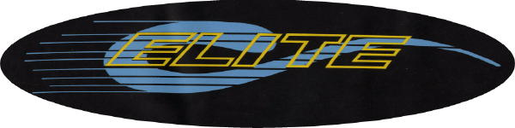

*ELITE SWIMMERS*

JOIN THE 2011
“ELITE-A-THON” &

RAISE MONEY FOR THE CHARITY OF YOUR CHOICE

Who: All Elite Swimmers
When: Saturday May 21nd 3:15-5:15 pm
Where: Morristown Beard Pool

To participate, simply:

* Choose a charity
* Ask family and friends to sponsor you
* Swim between 3:15 pm-5:15 pm on Saturday, May 21
* Stick around after for snacks/drinks
* Report back to your sponsors, ask them to provide you a check in the name of the charity you designated
* Report your charity & the sum of your donations to
Lindsaystearns14@yahoo.com
* Thank everyone who sponsored you
* Mail your donations to your designated charity by June 15th

If you have any questions, please contact Lindsay Stearns Lindsaystearns14@yahoo.com
Past Charities

❑ Crohn’s & Colitis Foundation of America
❑ National Organization for Rare Disorders
❑ DeGeorges Syndrome
❑ Pax, Real Solutions to Gun Violence
❑ Habitat for Humanity
❑ Napalese Youth Opportunity Foundation
❑ Jersey Animal Coalition
❑ The Make a Wish Foundation
❑ Cora Hartshorn Arboretum and Bird Sanctuary
❑ All God’s Children
❑ Susan G. Komen Breast Center
❑ Community Soup Kitchen, Morristown
❑ The Jimmy Fund
❑ Save the Children
❑ Starlight Foundation
❑ The Lenny George Fund
❑ Salvation Army
❑ American Cancer Society
❑ Our House Foundation

Thank you in advance for participating in the
2011 Elite Swim-a-thon

